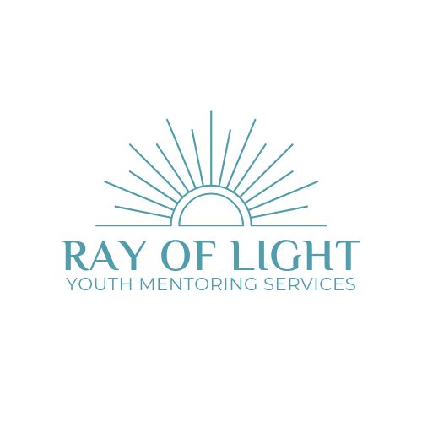

**Why choose Ray of Light Youth Mentoring Services?**

Ray of Light Mentoring, located in Southend-on-Sea, Essex, was founded with the mission to empower young people to transform their lives. Our life coaching and mentoring services are designed to provide support, guidance, and actionable strategies to help young people overcome challenges, build resilience, self-esteem and confidence, and to achieve their goals.

We believe that everyone has the potential to shine bright, and our role is to help uncover that potential. We offer personalised coaching that meets each individual's unique needs, including personal development, behavioural improvement, stress management, breath-work techniques and help with transitions (to new schools/colleges/homes etc), ensuring a holistic approach to well-being.

Phil Ray, Director, has undergone all necessary training and holds qualifications in both Life Coaching and specifically Teen Life Coaching in order to provide personalised coaching.

Qualifications include:

Professional Life Coach

Teenage Life Coach

Autism and ADHD in Girls

Children and Bereavement

Understanding Children’s Emotions

Nutrition and Healthy Eating

Breathwork Teacher Training Certificate

Children’s Breathwork Teacher Training Certificate

Mindful breathing with Children and Teens

Online Safety

Safeguarding Level 1, 2 and 3 (Designated Safeguarding Lead)

Basic First Aid

Having worked as a Youth Worker, a Football Coach within a local youth setting, and a youth mentor within a local Alternate Education Provision for young people struggling in mainstream education, Phil set up Ray of Light Youth Mentoring to offer his services to private clients, including families, care homes, youth groups and schools. Phil brings knowledge, experience and expertise to every session.  Phil is also a parent of two children (now adults) and has a very empathetic and relaxed style to his work.





**Background**

In 2024, the UK has faced a concerning trend often referred to as a "Happiness Recession" among its young population. Research, including The Children's Society's Good Childhood Report, highlights that UK young people rank lowest in life satisfaction across Europe,

This alarming statistic underscores the urgent need for effective interventions to support young people's wellbeing.

One promising approach to counteract this decline in happiness is through mentoring. Mentoring provides young people with a trusted adult who can offer guidance, support, and a listening ear. This relationship can be particularly impactful for several reasons:

1. **Emotional Support**: Mentors can help young people navigate the complexities of adolescence, providing a safe space to express their feelings and concerns. This emotional support is crucial in building resilience and improving overall mental health.
2. **Positive Role Models**: Having a mentor exposes young people to positive role models who can inspire and motivate them. This can be especially beneficial for those from disadvantaged backgrounds, who may lack such influences in their immediate environment.
3. **Skill Development**: Mentors can assist young people in developing essential life skills, from academic support to career guidance. This not only boosts their confidence but also equips them with tools to achieve their goals, fostering a sense of purpose and satisfaction.

4.      **Social Connection**: Mentoring helps young people learn how to build and maintain meaningful social connections. This guidance is vital for their happiness, as it reinforces their sense of belonging and community.

Given the current state of young people's wellbeing in the UK, mentoring is not just beneficial but essential. By investing in mentoring programs, we can provide the support and guidance needed to help young people thrive, ultimately improving their perceived happiness and overall quality of life.

Mentoring can benefit a wide range of young people, not just those who are perceived as having behavioural issues. Here are some groups of young people who can greatly benefit from mentoring:

1. **Youth with Behavioural Challenges**: While not the only group, those with behavioural issues can benefit from the structure, guidance, and positive influence that mentors provide.
2. **Academically Struggling Students**: Mentors can offer support, help set goals, and provide encouragement, which can improve school performance and attitudes towards learning.
3. **Young People with Low Self-Esteem**: Mentoring can help build confidence and a sense of self-worth through consistent support and positive reinforcement.
4. **Young People with Anxiety**: Mentors can provide a supportive and understanding presence, helping to build coping strategies and confidence in social situations.
5. **Socially Awkward or Reserved Individuals**: Mentoring can help these young people develop social skills, build self-esteem, and learn how to form and maintain meaningful relationships.
6. **Young People Facing Life Transitions**: Whether it's transitioning to a new school, dealing with family changes, or preparing for adulthood, mentors can provide guidance and stability during these times.
7. **Those from Disadvantaged Backgrounds**: Mentors can offer positive role models and expose young people to opportunities and experiences they might not otherwise have.

Mentoring is a versatile and valuable support system for all young people, regardless of their specific challenges or backgrounds, and can have a broad impact on improving the overall wellbeing and happiness of students.



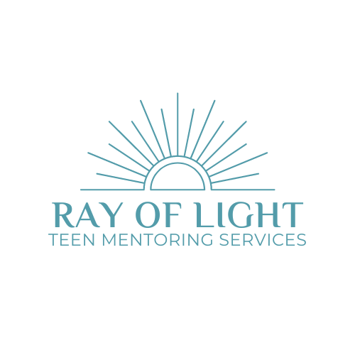

**At Ray of Light Youth Mentoring Services,** we focus on building strong, supportive relationships with young people, making sure they feel valued and listened to. Our approach creates an inclusive environment that encourages trust and open communication.   By focusing on kindness, we create a nurturing atmosphere that is both effective and worthwhile, cultivating a sense of belonging and respect.

Our Approach:

**Relational Focus:** Instead of using punishments or punitive approaches, we use positive relationships to encourage good behaviour. We have meaningful conversations and help children learn to manage their emotions and actions better.

Relational focus is about prioritising the quality of the relationship between mentor and student. This approach emphasises building trust, understanding, and a deep connection, which are essential for effective outcomes. Instead of focusing solely on achieving specific goals or correcting behaviours, relational focus aims to create a supportive environment where the student feels valued and understood.

Key Elements of Relational Focus:

1. **Deep Connection:** Establishing a genuine, warm, and open-hearted relationship with the student. This connection helps in creating a safe space for the student to share their thoughts and feelings.
2. **Empathy and Reflection:** Encouraging the student to empathise and self-reflect on their behaviours. By holding up a mirror to their behaviour and considering its impact on others, students learn to develop empathy, self-awareness and make more thoughtful decisions
3. **Supportive Environment:** Creating an environment that prioritises support over punishment. This includes using restorative conversations and activities that promote positive behaviour and emotional regulation.
4. **Positive Outcomes:** The relational approach is linked to better behavioural and emotional outcomes for young people. When students feel understood and supported, they are more likely to engage positively and make meaningful changes in their behaviour

**Breathwork Techniques:** We place a strong focus on breathwork techniques, which are highly effective for regulating emotions and reducing stress. Teaching students how to use controlled breathing helps them manage anxiety, stay calm in challenging situations, and improve their overall emotional well-being.

**Inclusive Practices:**We work to keep students in school and make everyone feel included. We use a system that gives students the help they need during lessons, helping them calm down, fix any issues, and get back to learning smoothly.

**Continuous Support:** For students who have big challenges, we look at their situation from all angles to find helpful solutions. Our goal is to provide ongoing, positive support and never give up on any child.

Our Impact: Our kind, informed approach has led to significant improvements in student behaviour and relationships. Our methods increase resilience and confidence in students, promote better trust between students and teachers, more disclosures of personal issues, and a more positive school environment overall.





**Examples:**

1.      **Confidence Building:**

•        A young person struggling with self-esteem issues can began to open up during our sessions. Through consistent support and positive reinforcement, they gain the confidence to participate more actively at home and in school.

2.      **Behaviour Improvement:**

•        A young person with frequent behavioural issues, can, by focusing on building a trusting relationship and using restorative conversations, learn to manage their emotions better. Over time, their incidents of misbehaviour can significantly decrease both in their home environment and at school/college.

3.      **Emotional Regulation:**

•        A young person with anger management problems can benefit from our co-regulation techniques. We focus on breathwork techniques and use activities like walking and talking to help them calm down and reflect on their actions. This approach helps them develop better coping strategies and improves their interactions with peers, caregivers and teachers.

 Additionally our approach has also led to improved school attendance, as young people feel more supported and motivated to attend school regularly.



**Mentoring Sessions Overview**

**Session Cost:**

•       **Single Session:** Each mentoring session cost £65.00.

Programmes/multiple sessions can be arranged at a discount. Please contact us with your requirements and we will look at building an affordable, tailored programme for you.

**Structure and Duration:**

•       **Session Length:** Each mentoring session lasts approximately **60 minutes**.

•       **Number of Sessions:** Typically, a young person may need around **6-10 sessions** to see significant progress, though this can vary based on individual needs. We try not to look at things on a ‘one size fits all’ basis as this can be too prescriptive and some young people will require only a few sessions and others significantly more.

**Session Breakdown:**

1.      **Initial Assessment:**

•        **Purpose:** Understand the young person's unique challenges, strengths, and goals.

•        **Activities:** Conversations to build rapport, initial assessments, and setting goals.

2.      **Ongoing Sessions:**

* + **Focus Areas:**

**Emotional Regulation:** Techniques such as breathwork and mindfulness to help manage stress and emotions.

**Confidence Building:** Activities and discussions aimed at boosting self-esteem and resilience.

**Behaviour Improvement:** Restorative conversations to address behavioural issues and promote positive changes.

•      **Methods:** A mix of 1:1 conversations, reflective exercises, and practical activities tailored to the young perosn’s needs.

3.      **Review and Reflection:**

•     **Purpose:** Evaluate progress, reflect on achievements, and adjust goals as needed.

•     **Activities:** Reflective discussions, feedback sessions, and planning for future steps.

**Supportive Environment:**

•        **Approach:** Sessions are designed to be supportive and non-punitive, focusing on building trust & understanding.

•        **Techniques:** We use a relational focus to create a safe space where students feel valued and heard.

**Expected Outcomes:**

•      **Improved Behaviour:** Reduction in behavioural issues and better emotional regulation.

•      **Increased Confidence:** Enhanced self-esteem and resilience.

•      **Better Relationships:** Stronger trust and communication between young people, peers, teachers and care givers.

•      **Improved school attendance:** Young people feel more supported and motivated to attend lessons/school regularly.

Our mentoring sessions aim to provide continuous, positive support, helping young people navigate their challenges and achieve their full potential. If you have any specific questions or need further details, feel free to ask.





**REFERENCES (Others available on request)**

“*As the founder and lead of a local behaviour intervention centre/alternative education provision, I have had the privilege of observing Phil working closely with challenging students across all academic key stages.*

*In his role as a mentor, Phil has demonstrated patience, understanding, and calmness in his interactions with students who have struggled in mainstream education. These students often face significant barriers to learning, including behavioural challenges and emotional difficulties, but Phil approaches every situation with a level-headed, supportive demeanour. Phil remains calm, even in high-pressure situations, allowing for a great effect on the students he works with*.”

Jack O’Connor, Founder & Director, EH4CP

07769 221375

“*I am writing to provide a reference for Phil Ray, who is an invaluable asset as a youth worker in our youth club and within an education setting held on our site for young people struggling in mainstream education.*

*During his time with us, Phil has demonstrated remarkable dedication, empathy, and effectiveness in supporting and mentoring young people. He has worked tirelessly to build strong, trusting relationships with the teenagers, offering guidance, support, and a listening ear when needed.*

*Phil possesses excellent communication skills, both with the young people and with colleagues. He has been able to adapt his approach to meet the diverse needs of the youth we serve, showing great sensitivity to their individual circumstances and challenges.*

*In the youth club, Phil volunteers his time and is extremely reliable. He has recently been awarded a Jack Petchey award for his services to young people.*

*In the educational setting, Phil has proven to be a positive role model, consistently encouraging and motivating the teenagers to engage in their learning and develop their skills.*

*One of his standout qualities is his ability to remain patient and calm in challenging situations. This quality has been particularly valuable when working with teenagers with challenging behaviour, where Phil’s composed and supportive demeanour has helped de-escalate conflicts and create a positive environment.*

*Overall, Phil has shown exceptional commitment to making a difference in the lives of young people, and strongly recommend him for any position that requires dedication, compassion, and a genuine passion for youth work.*”

Anna Sims, Youth Lead, Garon Park CIC

07952 605915

